**Tanner Wale**

**Module 2-4 activity sandboxing part one**

**CYB 220 Network Security**

**3/6/23**

**The configurations of PC1, PC2, Server, and configuration of Router**

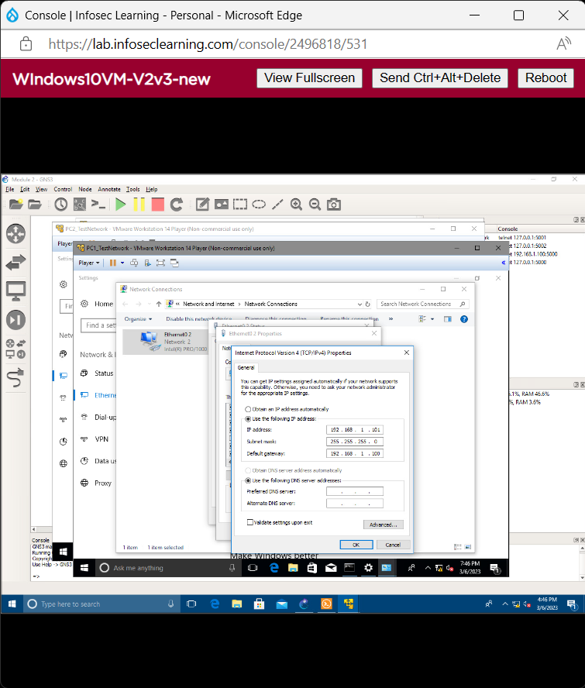

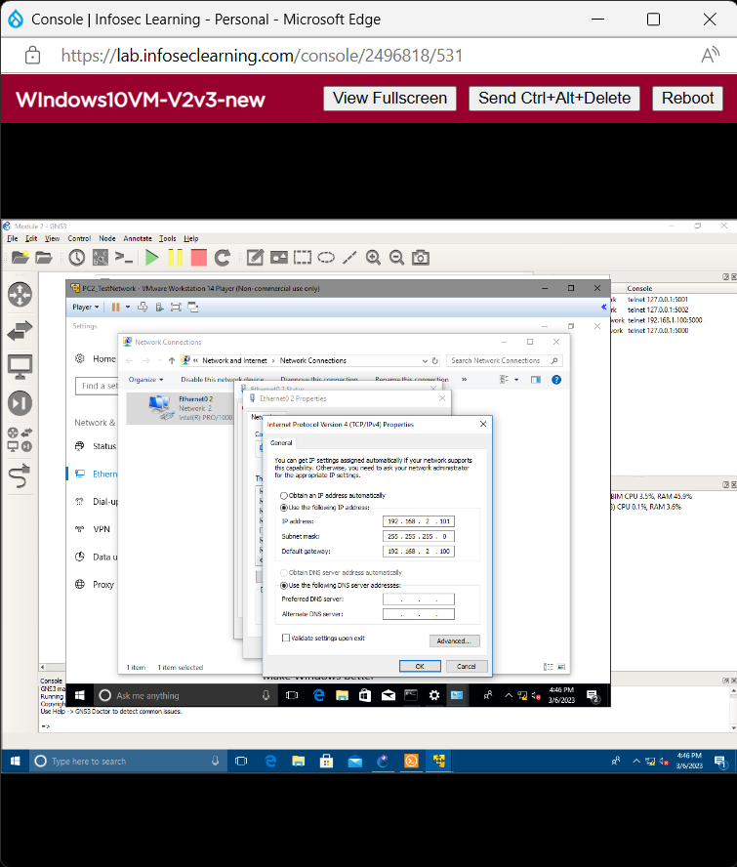

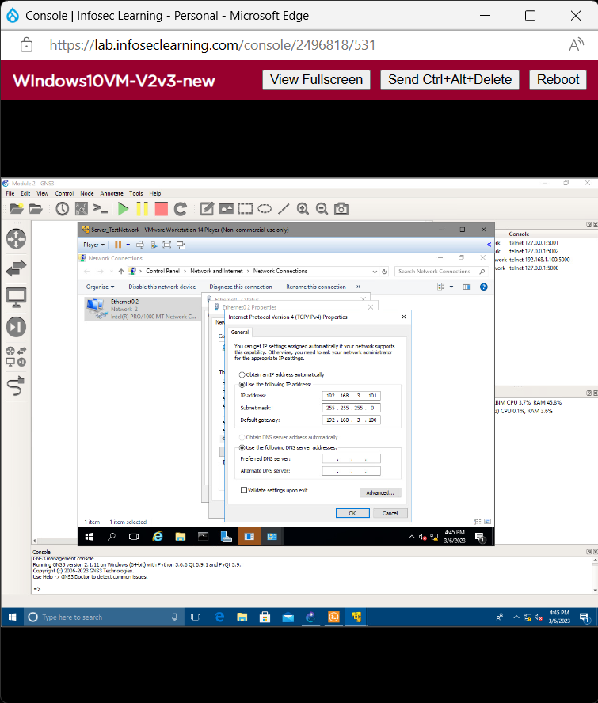

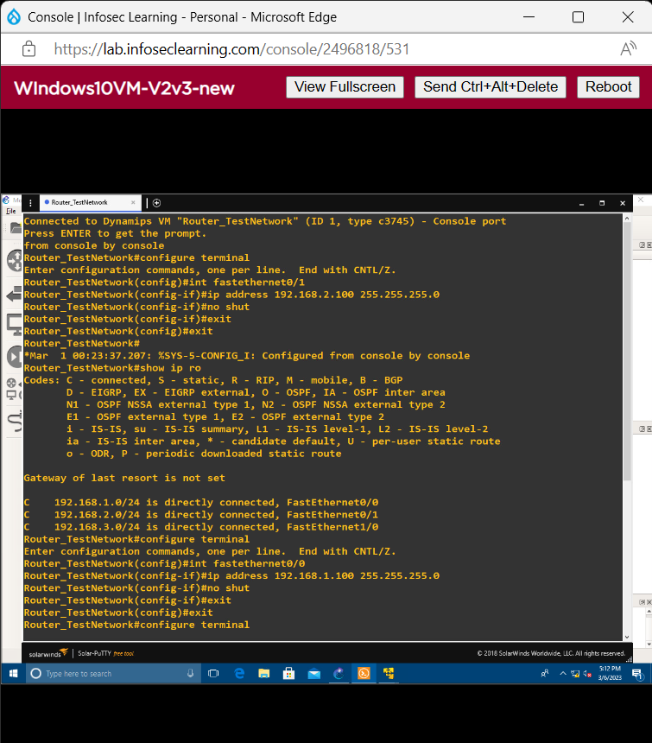**Submit a screenshot of the topology**

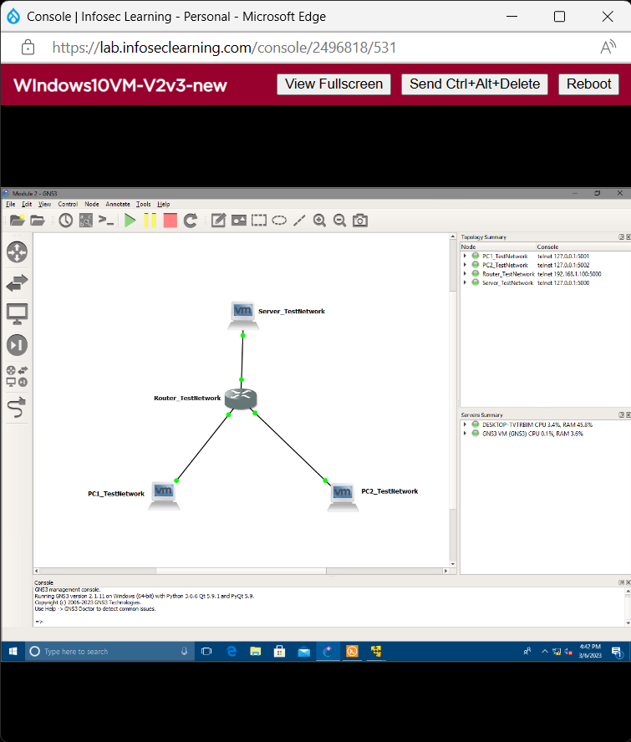

**From PC1_TestNetwork to PC1_TestNetwork,**

**From PC1_TestNetwork to PC1_TestNetwork Gateway**

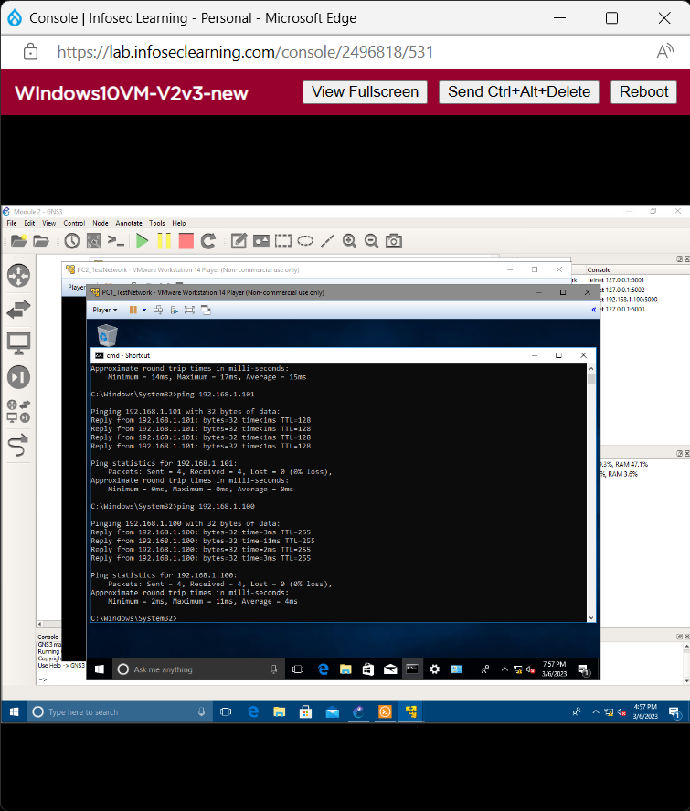

**From PC1_TestNetwork to PC2_TestNetwork Gateway,**

**From PC1_TestNetwork to PC2_TestNetwork**

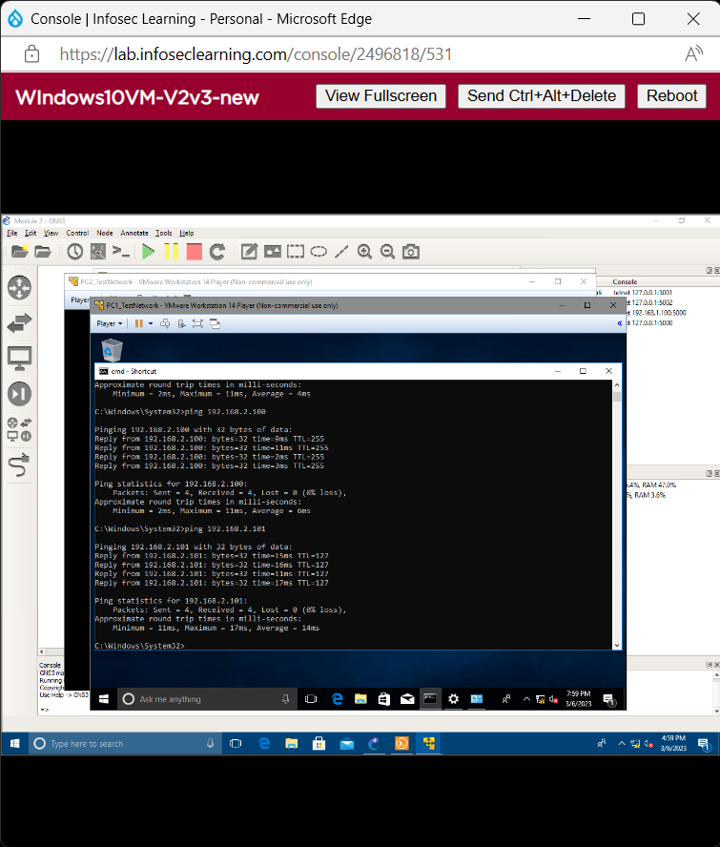

**From PC2_TestNetwork to PC1_TestNetwork,**

**From PC2_TestNetwork to Server_TestNetwork**

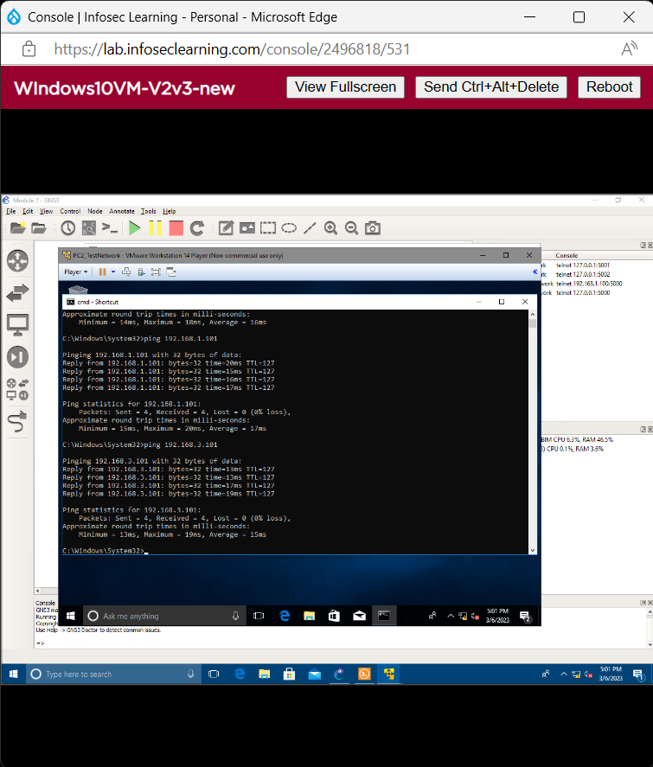

**From Server_TestNetwork to PC1_TestNetwork,**

**From Server_TestNetwork to PC2_TestNetwork**

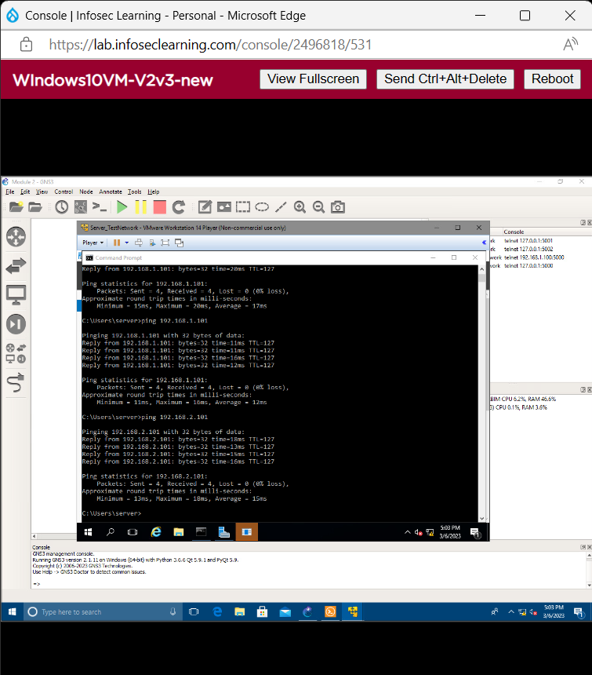

**From PC1_TestNetwork to Server_TestNetwork**

